Project Manager

Our Purpose…

… We dream of a simpler, greener energy market; powered by our investment in innovation and passion for customers.

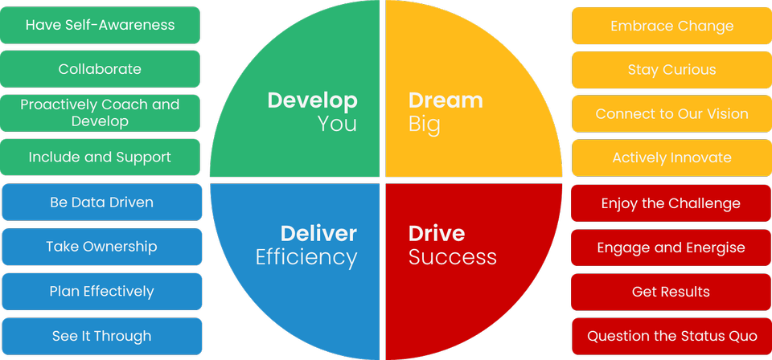

Some ’great to haves’ are…

* An experienced Project Manager practitioner, used to managing either single, or multiple and complex projects and working within an AGILE framework.
* Formal Project Manager qualifications.
* Energy industry awareness including central body responsibilities
* Experience managing complex IT projects/programmes

My Purpose…

The **Project Manager** delivers secure, effective, and cost-efficient technology change whilst working within an iterative schedule. When run live, supports our business objectives and those of our customers.

The key capabilities I will use every day are…

* Communication and stakeholder management
* Risk, opportunity, and issue management
* Schedule management
* Consolidated planning
* Financial management
* Change control
* Quality management
* Contributing to Iteration Planning and User Story and Feature development and completion.
* Ability to work within an Agile framework and provisioning of daily support to the Product Owners.

The impact I will have on customers is…

* Leading an excellent customer experience throughout the project lifecycle.
* Minimising the impact of delivery risks through effective management.
* Providing a clear understanding of the impact of change through clear and concise communication.
* Projects are implemented on time, on budget, to quality and meet customer requirements.
* Delivering an excellent customer experience during project implementation

The behaviours I embody will be…

Read below to find out the **serious stuff**!