GRC Lead

Our Purpose…

… … We dream of a simpler, greener energy market; powered by our investment in innovation and passion for customers.

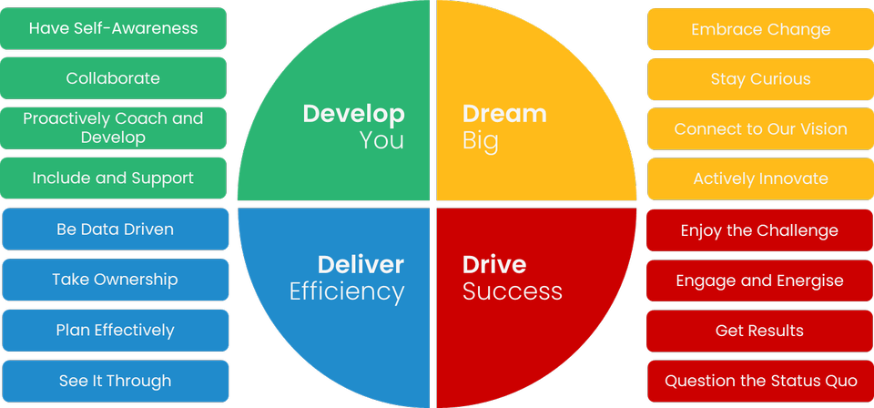

Some ’great to haves’ are…

* CISA
* ISO 27001 Lead Auditor
* Enterprise Risk Management Certified Professional (ERMCP), Certified Risk Manager (CRM) or Certified Risk Management professional (CRMP)
* Accountancy qualification, such as Chartered Accountant (CA, CPA, ICAEW, ACCA)

The key capabilities I will use every day are…

* Stakeholder Management
* Risk, opportunity, and issue management
* ISO27001, NIST Cyber Security, PCI DSS
* Governance
* Teamwork
* Continuous Improvement

The behaviours I embody will be…

The impact I will have on customers is…

* To reduce the likelihood and impact of risk by ensuring the operational, tactical and organisational controls have been defined to meet our compliance standards.
* to provide subject matter expert advice to internal and external stakeholders and hands-on operational application of Risk management and methodologies.
* Ensuring Correla effectively manage corporate and strategic risk and compliance with standards and best practice for all in a cost-effective way.

My Purpose…

…is to engage with business stakeholders to identify risks, opportunities, and issues; implement effective risk methodologies and framework to manage the strategic and operational corporate risk profile and assure the implementation of and compliance with industry standards across the organisation.

Read below to find out the **serious stuff**!