SaaS Change Delivery Manager

Our Purpose…

… We dream of a simpler, greener energy market; powered by our investment in innovation and passion for customers.

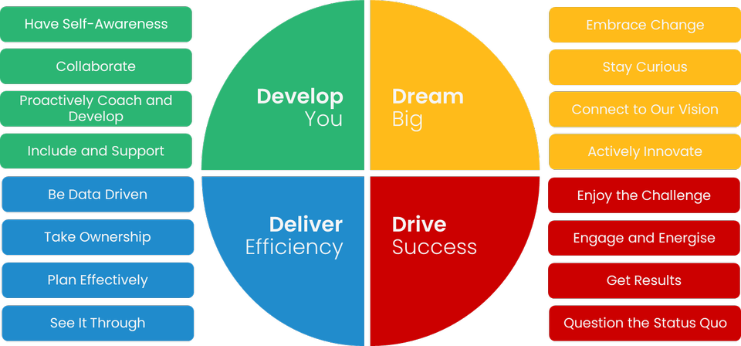

The impact I will have on customers is…   
  
Changes are implemented on time, on budget and meet customer requirements.  
Clear and accurate reporting to multiple stakeholders of project status.  
Provide insight that will be used for informed decision-making to change outcomes for our clients or customers, as well as influence senior stakeholders.  
Building capability in our people across the change lifecycle to ensure high quality outcomes.

My Purpose…

The Change Delivery Manager leads a team that delivers secure, effective, and cost-efficient changes that support our business objectives and those of our clients & customers. Responsible for our change roadmap - ensuring we get the best out of our people by effective workforce planning (inc. building capability); and the best value for money from our change delivery – including the tracking of benefits realisation.

Some ’great to haves’ are…

Experience managing multiple and complex changes & teams

Knowledge of product and agile delivery

Ability to manage “upwards” and solve challenges across a matrix organisation.

The key capabilities I will use every day are…

* Leadership
* Project Management
* Change Management and consolidated planning
* Portfolio governance, planning and reporting
* Risk, Opportunity and issue management
* Stakeholder & Communications management
* Procurement & contract management

The behaviours I embody will be…

Read below to find out the **serious stuff**!