Solution Architect

Our Purpose…

… We dream of a simpler, greener energy market; powered by our investment in innovation and passion for customers.

The key capabilities I will use every day are…

* Problem solving & innovative thinking
* Cloud solution architecture design
* Product Development
* Standards and documentation
* Collaboration & Commercial Acumen

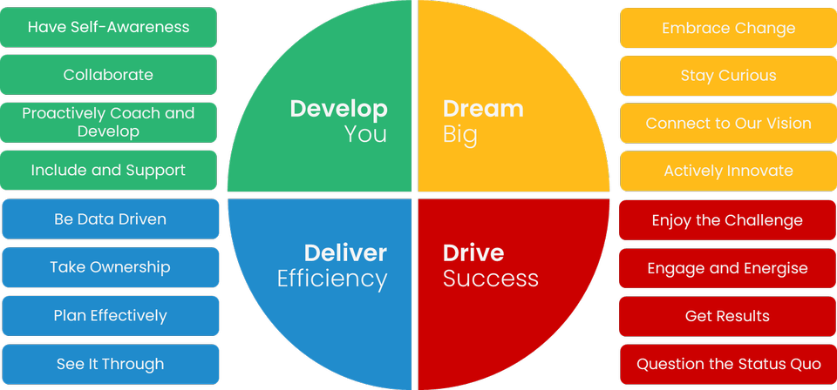

The impact I will have on customers is…

* Build, transform and improve digital services that will solve our customers’ problems and simplify the energy industry.
* Providing architectural governance to ensure solutions are aligned to the strategy and technology direction.
* Providing a non-technical interpretation of architecture and technology to management and business areas.

The behaviours I embody will be…

Some ’great to haves’ are…

* Significant Azure experience
* Energy industry experience
* Experience of setting standards for others to follow
* Certification in a relevant architecture framework (e.g. TOGAF)

My Purpose…

…is to work with the Engineering and Product departments to design and build platforms and products that serve our customers’ needs. Contributing to standards for system design and documentation and actively engaging in the design of products to provide new capabilities for our customers. Oversee the implementation and running of cloud-based systems, looking to continually improve.

Read below to find out the **serious stuff**!